Data Dictionary:
circuits.csv - Information on the circuit(track) including location, longitude, latitude and altitude.
- circuitId - Numerical id
- circuitRef - Short circuit name
- name - Full name of circuit
- location - City
- country - Country
- lat - Latitude
- long - Longitude
- alt - Altitude
- url - Url to circuit

constructor_results.csv - Information on the constructors(teams) championship result for each season.
- constructorResultId - Numerical id
- raceId - Numerical id {See races.csv}
- constructorsId - Numerical id {See constructors.csv}
- points - Points scored for a constructor at each race
- status - ???

constructor_standings.csv - Information on a constructor's standing at each race for each season.
- constructorStandingsId - Numerical id
- raceId - Numerical id {See races.csv}
- constructorsId - Numerical id {See constructors.csv}
- points - Points scored for a constructor at that point in a season
- position - Position for a constructor at that point in a season
- positionText - Position for a constructor at that point in a season string

constructors.csv - Information on the constructors.
- constructorsId - Numerical id
- constructorsRef - short team name
- name - Team name
- nationality - Nationality
- url - Wikipedia url

driver_standings.csv - Information on a driver’s standing at each race for each season.
- driverStandingsId - Numerical id
- raceId - Numerical id {See races.csv}
- driverId - Numerical id {See drivers.csv}
- points - Points scored for a driver at that point in a season
- position - Position for a driver at that point in a season
- positionText - Position for a driver at that point in a season string
- wins - Number wins for a driver at that point in a season
drivers.csv - Information on drivers.
- driverId - Numerical id
- driverRef - Short driver name
- number - Driver’s number
- code - Driver’s code
- forename - First name
- surname - Last name
- dob - Date of birth
- nationality - Driver nationality
- url - Driver’s wikipedia’s page

races.csv - Information on race including the year, circuit, and times for practice sessions, qualifiers, sprint races(if applicable), and the race.
- raceId - Numerical id
- year - Season year
- round - Race round in season
- circuitId - Numerical id {See circuits.csv}
- name - Circuit name
- date - Race date
- time - Race time
- url - Wikipedia url to circuit
- fp1_date - First practice date
- fp1_time - First practice time
- fp2_date - Second practice date
- fp2_time - Second practice time
- fp3_date - Third practice date
- fp3_time - Third practice time
- quali_date - Qualifying date
- quali_time - Qualifying time
- sprint_date - Sprint date
- sprint_time - Sprint time

results.csv - Information on each race’s result.
- resultId - Numerical id
- raceId - Numerical id {See races.csv}
- driverId - Numerical id {See drivers.csv}
- constructorId - Numerical id {See constructors.csv}
- number - Driver number
- grid - Starting position on grid for driver at raceId
- position - Finish place for driver at raceId
- positionText - Finish place for driver at raceId string
- positionOrder - Finish place for driver at raceId
- points - Points scored for driver at raceId
- laps - Total number of laps
- time - Total race time
- milliseconds - Total race time in milliseconds
- fastestLap - Lap number
- fastestLapTime - Lap time
- statusId - Numerical id {See status.csv}

sprint_results.csv - Information on each sprint race’s result. A subset of results.csv
- resultId - Numerical id {See results.csv}
- raceId - Numerical id {See races.csv}
- driverId - Numerical id {See drivers.csv}
- constructorId - Numerical id {See constructors.csv}
- number - Driver number
- grid - Starting position on grid
- position - Finish place
- positionText - Finish place string
- positionOrder - Finish place
- points - Points scored
- laps - Total number of laps
- time - Total race time
- milliseconds - Total race time in milliseconds
- fastestLap - Lap number
- fastestLapTime - Lap time
- statusId - Numerical id {See status.csv}

status.csv - Information on cars or drivers (DNFs, Retirements, DNS, Retirement Issues etc.)
- statusId - Numerical id
- status - Name

Dataset Transformation:
Weather dataset
- Date of weather record (YYYY-MM-DD)
- Location
  - Latitude (degrees)
  - Longitude (degrees)
  - Altitude (meters above sea level, optional)
- Temperature (degrees in Celsius/Fahrenheit)
- Rainfall (millimeters or inches)
- Weather conditions (categorical data: sunny, cloudy, rain, storm)
- Wind speed (meters per second or miles per hour)
- Humidity (percentage)

Race dataset
- Date of race (YYYY-MM-DD)
- circuitRef - Short circuit name
- Circuit name - Full name of circuit
- Race location
  - Latitude (degrees)
  - Longitude (degrees)
  - Altitude (meters above sea level, optional)
- Start time
- Time zone
- Race ID (numerical)
- Team names/ID (textual or numerical)
- Race results–positions of drivers and teams (numerical order)
- Race results–points scored by drivers and teams (numerical order)
- Race results–points and position standings by drivers and teams after each round (numerical order)
- Number of laps (count)
- Race duration (time in hh:mm:ss)
- Status
- Fastest lap number

Team spending/revenue dataset
- Year (YYYY)
- Team names/ID (textual or numerical)
- Total spending (currency value, e.g. USD or Euros)
- Revenue generated (currency value, e.g. USD or Euros)
- Team’s championship position by year-end (numerical order)
- Number of wins (count)
- Number of podiums (count)

Status -
Finished - Finished race
+1 Lap - Finished with 1 lap less than race winner
Wheel - DNF due to wheel issue
Engine - DNF due to engine issue
Steering - DNF due to steering issue
Brakes - DNF due to brake issue
Puncture - DNF due to tire puncture
Electrical - DNF due to electrical issues
Collision damage - DNF from collision damage (Could be driver error)
Accident - DNF due to accident (Could be driver error)
Collision - DNF due to collision (Could be driver error)
+2 Laps - Finished with 2 laps less than race winner
+3 Laps - Finished with 3 laps less than race winner
Gearbox - DNF due to gearbox
Oil leak - DNF due to oil leak
Turbo - DNF due to turbo issue
Exhaust - DNF due to exhaust issue
Fuel pressure - DNF due to fuel pressure issue
Hydraulics - DNF due to hydraulics issue
Power Unit - DNF due to power unit issue
Tyre - DNF due to tyre issues
Retired - Car retired and DNF
Power loss - DNF due to power loss
Suspension DNF due to suspension issue
Disqualified - Car or Driver disqualified
Mechanical - DNF due to mechanical issue
Battery - DNF due to battery issue
Overheating - DNF due to overheating issue
Damage - DNF from damage (Redundant) (Could be driver error)
Out of fuel -DNF due to lack of enough fuel left in car
Transmission - DNF due to transmission issue
Spun off - DNF due to driver spinning off (Driver Error)
Water pressure - DNF due to water pressure issue
Withdrew - Driver or car withdrawn from race
Electronics - DNF due to electronics issue
+5 Laps - Finished with 5 laps less than race winner
Debris - DNF due to debris on track
Radiator - DNF due to radiator issue
Illness - Driver ill and didn’t race
Wheel nut - DNF due to wheel nut issue
Driveshaft - DNF due to driveshaft issue
Rear wing - DNF due to rear wing issue (probably damage from collision)
Cooling system - DNF due to cooling system issue
Water pump - DNF due to water pump issue
Fuel leak - DNF due to fuel leak
Front wing - DNF due to front wing issue (probably damage from collision)
Water leak - DNF due to water leak issue
Vibrations - DNF due to vibrations
Fuel pump - DNF due to fuel pump issue
Undertray - DNF due to floor damage (probably damage from collision or driver hitting kerbs)
+6 Laps - Finished with 6 laps less than race winner
Differential - DNF due to differential

Screenshot showing cost between 2015 and 2019
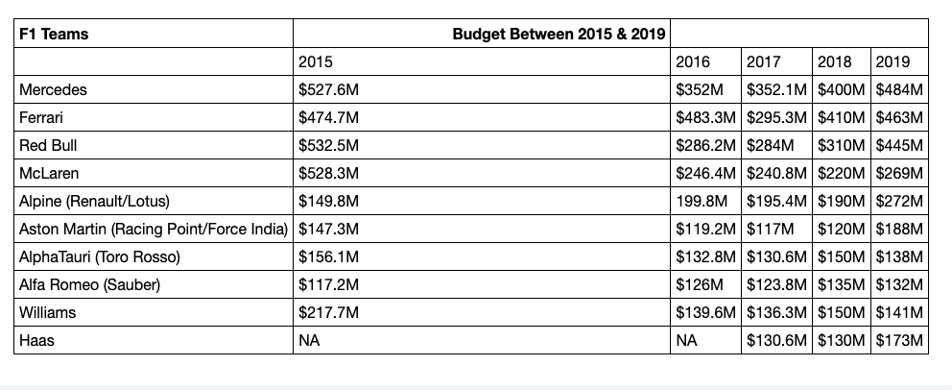

Questions:
- How does weather affect the results of F1?
- How does abnormal weather (rain or too hot) conditions affect the role it plays in driver position by the end of each year from 2018-2022?
  - Can join weather and race datasets on latitude, longitude, altitude
  - Can join race and spending/revenue datasets on team names or team id

